REQUEST FOR INFORMATION
VISN 23 is requesting information for companies who offer the following goods or equivalent. THIS IS A REQUEST FOR INFORMATION (RFI) ONLY: The market research is looking to identify potential vendors who have the capabilities to offer the following: SIEMENS SYNGO DYNAMICS Server Upgrade

A. Description & Salient Characteristics
Required Line Items:
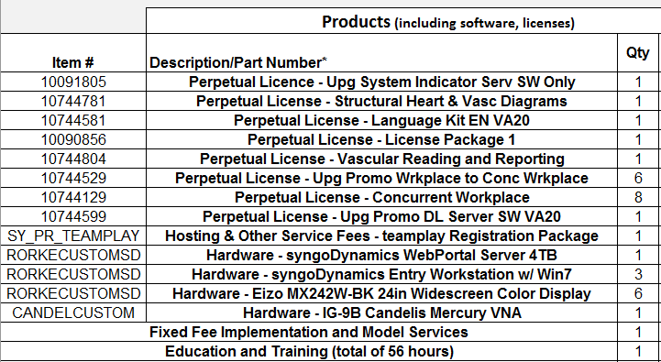

NAICS: 541519

If your company sells the Equipment listed above please contact me at Joshua.Imdacha@va.gov and provide the following information and any additional information that you deem pertinent:
Company Name | POC | Phone Number | Email Address | Product(s) | Duns | Business Size

DISCLAIMER
This RFI is issued solely for information and planning purposes only and does not constitute a solicitation. All information received in response to this RFI that is marked as proprietary will be handled accordingly. In accordance with FAR 15.201(e), responses to this notice are not offers and cannot be accepted by the Government to form a binding contract. Responders are solely responsible for all expenses associated with responding to this RFI.
Thank you,J
Joshua Imdacha
Contract Specialist

